SLST Precinct Rota System

# Project Concept

A precinct rota system, allowing for the precinct monitors of the SLST to manage their responsibly on an easy to use online system.

## Technologies

* Python 3.6 for backend/webserver
* (html, sass, js) skeleton for frontend design
* Jinja2 for templating

## Site Sections

### Administration

Login

User Management

Password Reset

### Precinct

Timetable setup (times, days)

User allocation

Timetable preview

Signing in for precinct

### User

Login

Account Details

Password Reset

Unavailable Days

SLST Precinct Management System

# Analysis

## Objectives

* Provide an authentication system for administrators and students
* Allow students to indicate days they cannot complete precinct duty
* Allow students to sign in and out of their current precinct duty and for this to be tracked
* Display an easy to understand timetable of duties
* Allow administrators to define the precinct duty sessions for the week
* Allow administrators to view when students signed in and out

## Problem Identification

Currently the SLST struggles to manage its precinct. Often multiple students given the precinct are there at once and at other time there is no senior student present which can lead to issues with behaviour in the area. This is mainly due to the lack of organisation of the precinct as there is no official rota created.

By having the web based solution implemented the precinct rota can be easily managed and assigned for each time slot. If hosted on the internal network, all relevant staff and students could easily access it from any device to ensure effective organisation and management of the SLST precinct.

## Stakeholders

There are multiple parties who will be invested in this project, its completion and hopeful success. These include the students who are responsible for being on duty in the SLST precinct, the staff in charge of the SLST precinct and ensuring it is well looked after and also the students who use the precinct area as their place to chill out. Everyone should benefit from the system being implemented as it will provide a way to ensure there is always a responsible senior student monitoring the precinct area when it is in use.

## Problem Research

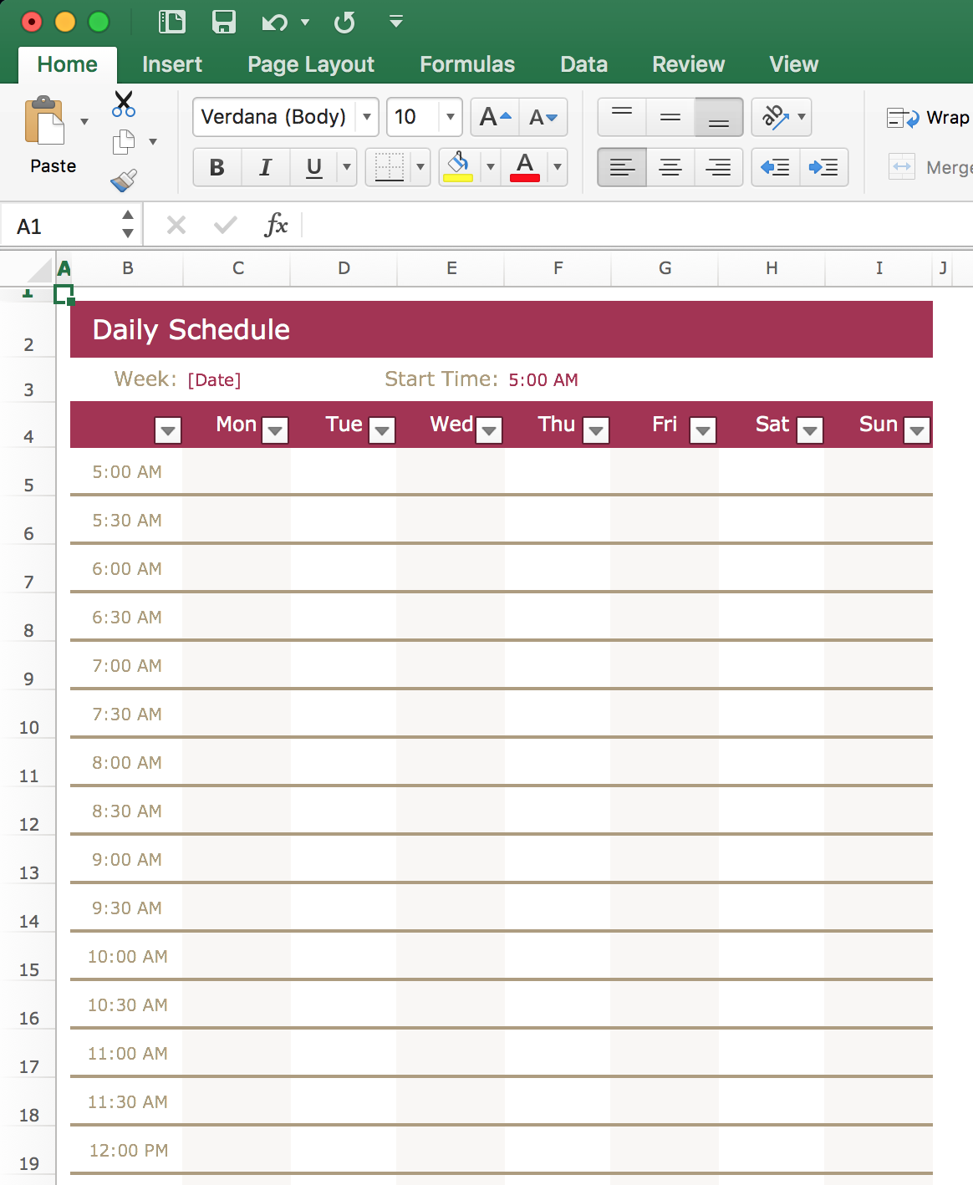One option that was viable instead of this system would be to use Excel (or any other spreadsheet software) and create yourself a timetable. This however has drawbacks as it becomes hard to share with all the students and staff who need access. Further, it would be very hard to control who has access to what parts of the spreadsheet except with very complicated VBA embedded into the document. In theory, this solution could be viable through a lot of work. The project aims to make the precinct management process easy and simple unlike this.

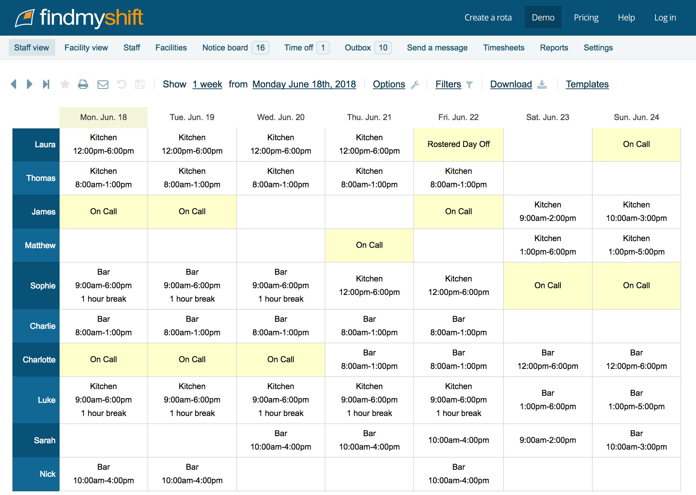Additionally, online solutions such as FindMyShift (<https://www.findmyshift.co.uk/>) exist but these are mostly business orientated and are not aimed at simplistic rota systems. With this software, it is designed to be scheduled week by week and not aimed for recurring weekly rota like we would want for stage. This software also has costs associated with more advanced versions of it to unlock all features. Therefor creating our own system will eliminate subscription costs and will mean it can be customised to our aim, a recurring weekly rota.

## Proposed Solution

Creating a web based precinct rota system, allowing for the precinct monitors of the SLST to manage their responsibly on an easy to use online system and provide staff of the precinct with an easy to view system for if the precinct monitors are handling their duties correctly.

### Technologies

* Python 3.6 used for backend, the webserver.
* Flask, a python package, used as the webserver itself.
* Jinja2 for templating in Python/Flask.
* Sass used for generating styling for the site.
* Skeleton CSS used as a base framework for site styling.
* JS used to handle all frontend interactivity, calendars etc.

# Design

## Solution Decomposition

The site that will provide the rota system will be broken down as follows to provide ease of access for both staff and the precinct monitor students.

The system will be orientated to be mainly student run as this is the way the stage team has always operated. The students will elect themselves for their precinct slots and the staff will be able to view this and override it.

### Administration

This is the access for the staff to manage the precinct.

Login – Allow staff to login and authenticate.

Password Reset – Allow staff to reset their password via email.

Student Management – Allow staff to allocate logins for the precinct monitors.

Timetable Setup (times, days) – Allow staff to define the time slots for the precinct.

User Allocation – Allows staff to assign students to precinct slots or change existing allocations.

Monitor Register – Allow staff to view when precinct monitors have signed in/out for their precinct.

### User

This is the area that the student precinct monitors will log into.

Login – Allow students to login.

Password Reset – Allow students to reset password via email.

User Allocation – Allow students to sign themselves up for precinct slots.

Timetable Preview – Allows students to see the full timetable with assigned monitors.

Precinct Register – Allows the student to sign in/out for their precinct slot.